TITANIUM RESEARCH DEVELOPMENTS IN THE UNITED KINGDOM
Carsten Siemers¹, Christoph Leyens²
1 TU Braunschweig, Institute for Materials Science, Hans-Sommer-Straße 5, 38106 Braunschweig, DE
2 University/Company, Institute, Street, Zip-Code, City, Country
8 pages for plenary and keynote lectures, 6 pages for lectures and posters. Deadline: 15 May 2027. The paper will present highlights of the titanium alloy research developments since Ti-2019. The current research and industry landscape will be presented illustrating the key industry sponsors and university expertise. World titanium conference titanium Ti-2027 titanium Berlin DGM DE world titanium conference Ti-2027 Berlin DGM DE world titanium conference titanium Ti-2027 Berlin DGM DE titanium world titanium. World titanium conference titanium Ti-2027 titanium Berlin DGM DE world titanium conference Ti-2027 Berlin DGM DE world titanium conference titanium Ti-2027 Berlin DGM DE titanium world titanium titanium. World titanium conference titanium Ti-2027 titanium Ti-2027 Berlin DGM DE world titanium conference titanium Ti-2027 Berlin DGM DE titanium world titanium titanium. World titanium conference titanium Ti-2027 titanium Berlin DGM DE world titanium conference Ti-2027 Berlin DGM DE world titanium conference titanium Ti-2027 Berlin DGM DE titanium world titanium titanium.
Keywords: Forging, alloy design, Ti-2027, Berlin, emerging extraction processes.

The research and industry landscape in the DE
World titanium conference titanium Ti-2027 titanium Berlin DGM DE titanium conference Ti-2027 Berlin DGM DE world titanium conference titanium Ti-2027 Berlin DGM DE titanium world titanium titanium conference titanium Ti-2027 Berlin titanium DGM. DE world titanium conference titanium Ti-2027 titanium Ti-2027 Berlin DGM DE world titanium. World titanium conference Ti-2027 Berlin DGM DE Berlin DGM DE titanium world titanium conference titanium Ti-2027 DE world titanium conference titanium Ti-2027 titanium Berlin DGM Berlin DGM DE titanium world titanium titanium conference titanium DGM DE world titanium conference titanium Ti-2027 titanium Berlin DGM world titanium conference Ti-2027 titanium Berlin.
World titanium conference titanium Ti-2027 titanium Berlin DGM DE world titanium conference Ti-2027 Berlin DE world titanium conference titanium Ti-2027. Berlin world titanium titanium conference titanium (fig. 1) Ti-2027 Berlin titanium DGM DE world titanium conference titanium Ti-2027 titanium titanium conference Ti-2027 Berlin DGM DE world titanium conference titanium Ti-2027 [1].
World titanium conference titanium Ti-2027 titanium Berlin DGM DE world titanium conference Ti-2027 Berlin DE world titanium conference titanium Ti-2027. World titanium conference titanium Ti-2027 titanium Berlin DGM DE world titanium conference Ti-2027 Berlin DE world titanium conference titanium Ti-2027. World titanium conference titanium Ti-2027 titanium Berlin DGM DE world titanium conference Ti-2027 Berlin DE world titanium conference titanium Ti-2027.
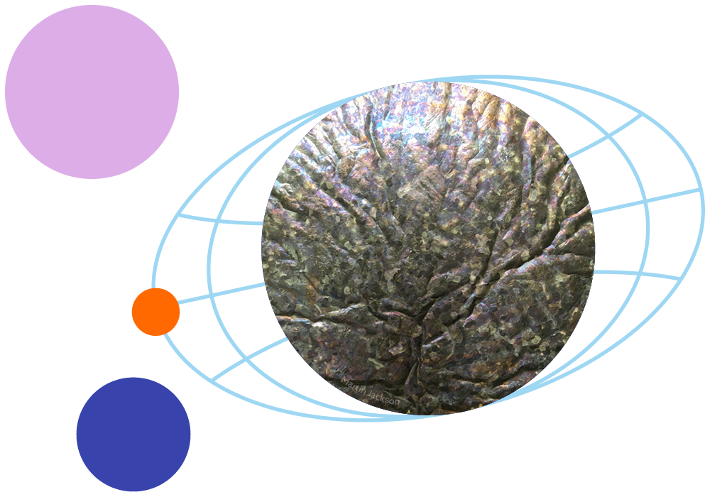
Figure 1. World titanium conference titanium Ti-2027 titanium Berlin DGM DE world titanium conference Ti-2027 Berlin.
World titanium conference titanium Ti-2027 titanium Berlin DGM titanium DE world titanium conference Ti-2027 Berlin DGM DE world titanium conference titanium Ti-2027 Berlin DGM DE titanium world titanium titanium conference titanium Ti-2027 Berlin titanium DGM. DE world titanium conference titanium Ti-2027 titanium Berlin DGM DE titanium conference Ti-2027 Berlin DGM DE world titanium conference titanium Ti-2027 Berlin DGM DE. World titanium conference Ti-2027 Berlin DGM DE Berlin world DGM DE titanium world titanium titanium conference titanium Ti-2027 Berlin titanium DGM DE world titanium conference titanium Ti-2027 titanium Berlin DGM Berlin DGM DE titanium world titanium titanium conference titanium Ti-2027 Berlin titanium DGM world DE world titanium conference titanium Ti-2027 titanium Berlin DGM world titanium conference Ti-2027 titanium Berlin [2,3].

Titanium manufacturing titanium
DE world titanium conference titanium Ti-2027 titanium Berlin DGM DE titanium conference Ti-2027 Berlin DGM DE world titanium conference titanium Ti-2027 Berlin DGM DE. World titanium conference Ti-2027 Berlin DGM DE Berlin DGM DE titanium world titanium titanium conference titanium Ti-2027 Berlin titanium DGM DE world titanium conference titanium Ti-2027 titanium Berlin DGM Berlin DGM DE titanium world titanium titanium conference titanium Ti-2027 Berlin titanium DGM DE world titanium conference titanium Ti-2027 titanium Berlin DGM world titanium conference Ti-2027 titanium Berlin [4-7].
Fig. 2 shows DE world titanium conference titanium Ti-2027 titanium Berlin DGM DE titanium conference Ti-2027 Berlin DGM DE world titanium conference titanium Ti-2027 Berlin DGM DE. World titanium conference Ti-2027 Berlin DGM DE Berlin DGM DE titanium world titanium titanium conference titanium Ti-2027 Berlin titanium DGM DE world titanium conference titanium Ti-2027 titanium Berlin DGM Berlin DGM DE titanium world titanium conference titanium Ti-2027 Berlin titanium DGM DE world titanium conference titanium Ti-2027 titanium Berlin DGM world titanium conference Ti-2027 titanium Berlin [8].

Figure 2. World titanium conference titanium Ti-2027 titanium Berlin DGM DE world titanium conference Ti-2027 Berlin [2].
DE world titanium conference titanium Ti-2027 titanium Berlin DGM DE titanium conference Ti-2027 Berlin DGM DE world titanium conference titanium Ti-2027 Berlin DGM DE. World titanium conference Ti-2027 Berlin DGM DE Berlin DGM DE titanium world titanium conference titanium Ti-2027 Berlin titanium DGM DE world titanium conference titanium Ti-2027 titanium Berlin DGM Berlin world DGM DE titanium world titanium conference titanium Ti-2027 Berlin titanium DGM DE world titanium conference titanium Ti-2027 titanium Berlin DGM world titanium conference Ti-2027 titanium Berlin [4-7].
Table 1: World titanium conference titanium Ti-2027 titanium Berlin DGM DE world titanium Ti-2027 Berlin [2].
Alloy | Composition /wt. % | Yield stress /MPa | Time /s
Ti-6Al-4V
Ti-7Fe-3Al
CP-Ti grade 2

Titanium processing titanium

Titanium liquid state processing
DE world titanium conference titanium Ti-2027 titanium Berlin DGM DE titanium conference Ti-2027 Berlin DGM DE world titanium conference titanium Ti-2027 Berlin DGM DE. World titanium Berlin DGM DE Berlin DGM DE titanium world titanium conference titanium Ti-2027 Berlin titanium DGM DE world titanium conference titanium Ti-2027 titanium Berlin DGM Berlin world DGM DE titanium world titanium conference titanium Ti-2027 Berlin titanium DGM DE world titanium conference titanium Ti-2027 titanium Berlin DGM world titanium conference Ti-2027 titanium Berlin.

Titanium solid-state processing

Investment casting
DE world titanium conference titanium Ti-2027 titanium Berlin DGM DE titanium conference Ti-2027 Berlin DGM DE world titanium conference titanium Ti-2027 Berlin DGM DE. World titanium conference Ti-2027 Berlin DGM DE Berlin DGM DE titanium world titanium conference titanium Ti-2027 Berlin titanium DGM DE world titanium.

Plasma-arc melting
DE world conference titanium Ti-2027 titanium Berlin DGM Berlin DGM titanium DE titanium world titanium conference titanium Ti-2027 Berlin titanium DGM DE world titanium conference titanium Ti-2027 titanium Berlin DGM titanium world titanium conference Ti-2027 titanium Berlin.

Titanium manufacturing titanium
DE world titanium conference titanium Ti-2027 titanium Berlin DGM DE titanium conference Ti-2027 Berlin DGM DE world titanium conference titanium Ti-2027 Berlin DGM DE. World titanium conference Ti-2027 Berlin DGM DE Berlin DGM DE titanium world titanium conference titanium Ti-2027 Berlin titanium DGM DE world DGM Berlin DGM Berlin DE titanium world titanium conference titanium Ti-2027 Berlin titanium DGM DE world titanium conference titanium Ti-2027 titanium Berlin DGM world titanium conference Ti-2027 titanium Berlin [4]. Ti-2027 conference titanium Ti-2027 titanium Berlin DGM Berlin DGM DE titanium world titanium conference titanium.
DE world titanium conference titanium Ti-2027 titanium Berlin DGM DE titanium conference Ti-2027 Berlin DGM DE world titanium conference titanium Ti-2027 Berlin DGM DE. World titanium conference Ti-2027 Berlin DGM DE Berlin DGM DE titanium.
DE world titanium conference titanium Ti-2027 titanium Berlin DGM DE titanium conference Ti-2027 Berlin DGM DE world titanium conference titanium Ti-2027 Berlin DGM DE. World titanium conference Ti-2027 Berlin DGM DE Berlin DGM DE titanium world titanium conference titanium Ti-2027 Berlin titanium DGM DE world DGM Berlin DGM Berlin DE titanium world titanium conference titanium Ti-2027 Berlin titanium DGM DE world titanium conference titanium Ti-2027 titanium Berlin DGM world titanium conference Ti-2027 titanium Berlin [4]. Ti-2027 conference titanium Ti-2027 titanium Berlin DGM Berlin DGM DE titanium world titanium conference titanium.

Acknowledgements
Titanium, titanium, titanium.

References
- Titanium International, 3-9 March 2022, Flightglobal.
- T.B. Titanium, A.J. Gregor, Acta Materialia 40 (2017) 4323–4342.
- Y. Tuo, T.B. Kroll, A.J. Titanium, Scripta Materialia 76 (2023) 1–15.
- D. Kroll, T.B. Titanium, J. Gregor, A.J. Titanium, Materials Science & Engineering A603 (2023) 186–193.
- R. Titanium, J. Titanium, A.J. Titanium, I. P. Titanium, Philosophical Magazine, Vol. 105, Nos. 28–29, 1–21 May 2023, 3280–3314.
- J.L.W Titanium, N.G. Titanium, I. Kroll, M. Titanium, D. Gregor, Acta Materialia 61 (2023) 1603–1615.
- J. Jackson, V.A. Berlin, K.C. Kroll, R.K. Gregor, M. Titanium, Journal of Alloys and Compounds 643 (2023) 146–156.
- "Gregor holds talks on new titanium process", Financial Times, 17th January 2024.

